Software Requirements Specification
For
Business Management System
Lanka Tools (Pvt) Ltd

Version 1.0
Prepared by
Bhathiya Kannangara, Imanka Jayasiriwardena, Ruwnathi Narampanawa
Lanka Tools (Pvt) Ltd
07/13/2022

Revision History
Name | Date | Reason For Changes | Version
SRS | 07/13/2022 | First issue | 1.0

Approvals

Name | Signature | Title | Date | Version
Dr. Yasas Jayaweera |  | Project Board | 07/15/2022 | 1.0
Bhathiya Kannangara |  | Project Manager | 07/15/2022 | 1.0
H.F Athaf |  | Client | 07/15/2022 | 1.0

Table of Contents
Table of Contents ii
Revision History iii
Approvals iii
1. Introduction 1
1.1 Purpose 1
1.2 Document Conventions 1
1.3 Intended Audience and Reading Suggestions 3
1.4 Project Scope 3
1.5 References 3
2. Overall Description 4
2.1 Product Perspective 4
2.2 Product Features 5
2.3 User Classes and Characteristics 6
2.4 Operating Environment 6
2.5 Design and Implementation Constraints 7
2.6 User Documentation 7
3. System Features 8
3.1 Use Case Diagram 8
3.2 Use case Scenarios 8
3.2.1 Login to the system 8
3.2.2 View Profile 9
3.2.3 Manage Employees 10
3.2.4 Employee Attendance 11
3.2.5 Employee Salary 12
3.2.6 Update Employee 13
3.2.7 Remove Employee 14
3.2.8 Add Employees 15
3.3 Class Diagrams 16
3.4 Entity Relationship Diagrams 16
3.5 Activity Diagrams 16
4. External Interface Requirements 17
4.1 User Interfaces 17
4.1.1 Common Interfaces for admin and users 17
4.2 Hardware Interfaces 17
4.3 Software Interfaces 17
4.3.1 User Interface Prototyping 17
4.3.2 Web Application 17
4.3.3 Database 17
4.4 Communications Interfaces 18
4.4.1 Communication functions 18
4.4.2 Communication Security 18
5. Other Nonfunctional Requirements 19
5.1 Performance Requirements 19
5.2 Safety Requirements 20
5.3 Security Requirements 20
5.4 Software Quality Attributes 21
6. Other Requirements 22
7. Appendix A: Glossary 22

List of Tables
Table 1: System Functions 7
Table 2: Use case Scenario for System Login 10
Table 3: Use case Scenario for View Profile 11
Table 4: Use case Scenario for Manage Employees 12
Table 5: Use case Scenario for Employee Attendance 13
Table 6: Use case Scenario for Employee Salary Management 14
Table 7: Use case Scenario for Update Employee 15
Table 8: Use case Scenario for Remove Employee 16
Table 9: Use case Scenario for Add Employees 17

List of Figures
Figure 1: High level Architecture Diagram 6
Figure 2: Entity Relationship Diagram 18
Figure 3: Activity Diagram - View Salaries 19
Figure 4: Activity Diagram - View Employees 19
Figure 5: Activity Diagram - View Attendance 20
Figure 6: Activity Diagram - Update Attendance 20
Figure 7: Activity Diagram - Update Employees 21
Figure 8: Activity Diagram - System Login 21
Figure 9: Activity Diagram - Add Employee Details 22
Figure 10: Activity Diagram - Remove Employees 22
Figure 11: Activity Diagram - Update Employee Details 23
Figure 12: Activity Diagram - Update Salary Details 23
Figure 13 : Login Interface 24
Figure 14: View Attendance interface 25
Figure 15: Cash advances interface 25
Figure 16: Admin dashboard 26
Figure 17 : Employee Registration Interface 26
Figure 18: Schedule Management interface 27
Figure 19: Payroll interface 27
Figure 20: Add Attendance Interface 28
Figure 21: Add cash advance interface 28
Figure 22: Employee Update interface 29

Introduction

Purpose
This Software Requirement Specification (SRS) highlights the main objective of the Business management system for Lanka Tools (Pvt) Ltd Kandy Owned by Mr. H.F Athaf and this is a large-scale business organization which includes wholesale, retail dealer on constructions tools and Heavy vehicle Renting which are distributed among 5 branches located in Kandy, Kurunegala and Colombo. The existing business process has some major downfalls, main being the lack of man power for the paper based operation, and thus the day-to-day tasks that takes place are made complicated. To scale up the business operation while centralizing the whole operation sustaining with technology advancement, the owner has decided to digitalize the business operation.
This document contain the functional and non-functional requirements for the proposed system as specified by the client during the virtual meetings. This document defines the scope of the project and illustrates the criteria that the outcome will include.

Document Conventions
This SRS Document was prepared using Microsoft word 2013. Each main topic commenced on a new page. The line spacing throughout the document is 1.5. The font types used are Times New Roman and Arial. The title levels and their formatting are listed below:

Main Headings
- Font: Times New Roman
- Face: Bold
- Size: 18

Level Two Headings
- Font: Times New Roman
- Face: Bold
- Size: 14

Level Three Headings
- Font: Times New Roman
- Face: Bold
- Size: 12

Other Headings
- Font: Times New Roman
- Face: Normal and Underlined
- Size: 12

Body Text
- Font: Times New Roman
- Face: Normal
- Size: 12

Image & table captions
- Font: Times New Roman
- Face: Normal
- Size: 10

Intended Audience and Reading Suggestions
This document is intended for individuals such as developers, project managers, quality assurance engineers, and documentation authors directly involved in the design and development of SMART Business management system which includes program's capabilities and scope by explaining the implementation side of the system. The document includes both graphical and textual inner workings of the proposed system, illustrating how each capability works in detail. All readers can benefit from the introduction, overall description, and various functional and non-functional needs. This document may be read from any section as needed by the user.

Project Scope
By eliminating the need of manual paper based business operation, the suggested system would assist users in maintaining the employee profiles, attendance, leaves, cash advances and Payroll. The ultimate result will be an easy-to-use business management system that helps users to manage their operation digitally. The system and transactions will be more productive, efficient, and time-saving by using new technology and plugins.

Overall Description

Product Perspective
The project's end deliverable will be a responsive business management system. The product will include an interface and other features as described in the proposed project's product description document.

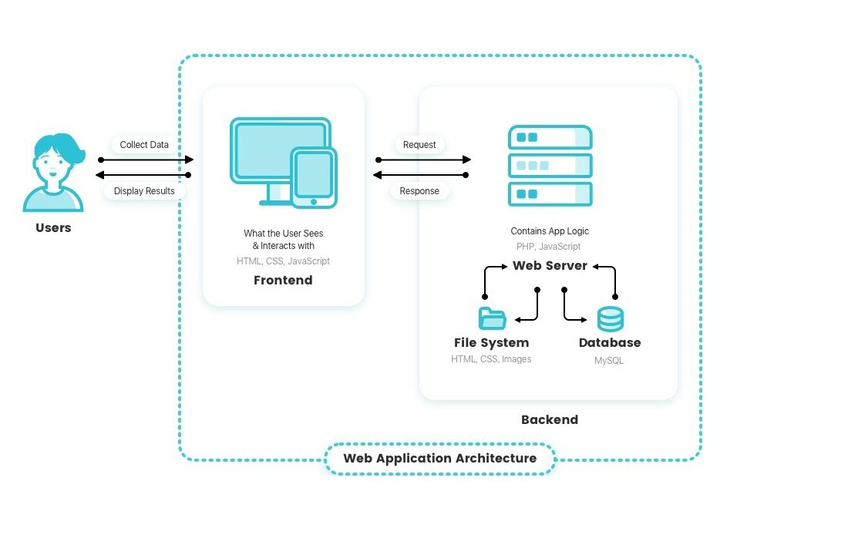
Figure 1: High level Architecture Diagram

Product Features
The tasks outlined here will provide a brief overview of each user's functions. These activities are addressed in further detail in Section 4.0, System Features.

Table 1: System Functions

User | Function
Admin | - Login to the system  - Add Employees  - View Employees  - Delete Employees  - Update Employees  - View & manage Budgets  - View & Manage Hourly rates and Salary scales  - View & manage Cash advances  - View & manage Salaries  - Upload Attendance  - View & manage Attendance  - Print Pay slips  - Report Generation
Employee | - Log-in to the system  - Creates a user account  - View and Manage Profile  - Add Attendance  - View Attendance  - Update Attendance  - Add Leaves  - View Leaves  - Update Leaves  - Add Cash Advances  - View Cash Advances  - View and Print Pay slips  - View Salary History  - Report Generation

User Classes and Characteristics
There will be two types of users engaging with the system.

- System Admin – The administrator has complete control over the system's functionalities, approvals and can manage the whole Business management system.

- Employees – Employees can manage their profiles, manage attendance and leaves, Report generation, request cash advances and view and print pay slips.

Operating Environment
Server Requirements
Web application will host in the shared hosting configured with following software and technologies
- Apache Web Server
- PHP 8.2
- MySQL
Client Requirements
On the users side, any modern device which has an active internet connection, and has any modern web browser installed will be able to use this business management web application.

Design and Implementation Constraints
The following design and implementation constraints might be considered in the design and implementation constraints of SMART Business management system for Lanka tools (Pvt) Ltd
- Time constraint – Month End of August, 2022 must complete the project.
- Cost constraint – No additional cost items are included within this project's scope.
- Proposed solution should responsive and support for all web browsers.
- Software licensing related processes are not deemed to be part of this project.
- Technology and organizational assessments of the current environment.
- Customer resource management and data mining components.
- Plugins and components for report generation and alerts and notifications

The project team is currently experiencing no major risks. However, due to the limited period and changing functionality based on the user, the team may experience planned possible risks when carrying out the project

User Documentation
The user manual will be sent with the system to provide instructions on how to use it effectively, and hands-on training will be provided during the user acceptance testing (UAT) phase. Additionally, Customer and technical support will be available during working hours.

System Features

Use Case Diagram

Use case Scenarios

Login to the system
Table 2: Use case Scenario for System Login

Use case ID: | Login
Use case Name: | Login to the system
Actors: | Admin
Preconditions: | The admin should be a registered admin.
Postconditions: | User could be logged into the system

 | Action | System response
Success Path: | - Admin Enter to the login page  - Admin submit the required details | - System request for login details  - System validates the details  - Enter the home page
Alternative Courses: | 4th Step – If admin enters the incorrect details, system should display an error message
Exception:
Special requirements:

View Profile
Table 3: Use case Scenario for View Profile

Use case ID: | View profile
Use case Name: | View Profile
Actors: | User
Preconditions: | The admin should be a registered user
Postconditions: | The user should be able to view his/her profile and do particular actions

 | Action | System response
Success Path: | - Click my profile | - Validate user  - Display the profile
Alternative Courses: | 4th Step – If admin is not logged in, system should display an error message
Exception:
Special requirements:

Manage Employees
Table 4: Use case Scenario for Manage Employees

Use case ID: | Manage employee
Use case Name: | Manage Employee
Actors: | Employee, Admin
Preconditions: | The admin should be a registered user
Postconditions: | Should be able to view list of employees

 | Action | System response
Success Path: | - Enter Login Details  3. Go to manage employees  5.view list of employees | 2.Validate details  4. Get list of the employees
Alternative Courses: | 2nd Step – If admin enters the incorrect details, system should display an error message
Exception:
Special requirements:

Employee Attendance
Table 5: Use case Scenario for Employee Attendance

Use case ID: | employee attendance
Use case Name: | Check Employee Attendance
Actors: | Employee, Admin
Preconditions: | The admin should be a registered user
Postconditions: | Should be able to check attendance of the employee

 | Action | System response
Success Path: | - Enter Login Details  3. Go to attendance  5.check attendance | 2.Validate details  4. Get attendance
Alternative Courses: | 2nd Step – If admin enters the incorrect details, system should display an error message
Exception:
Special requirements:

Employee Salary
Table 6: Use case Scenario for Employee Salary Management

Use case ID: | Manage salary
Use case Name: | Manage Salary
Actors: | Employee, Payroll manager
Preconditions: | The admin should be a registered user
Postconditions: | Payroll manager should be able to update salary records

 | Action | System response
Success Path: | - Enter Login Details  3. Go to salary records  4. Update salary records | 2.Validate details  5. Display message with records
Alternative Courses: | 2nd Step – If admin enters the incorrect details, system should display an error message
Exception:
Special requirements:

Update Employee
Table 7: Use case Scenario for Update Employee

Use case ID: | Update employee
Use case Name: | Update employee
Actors: | Employee, Payroll manager
Preconditions: | The admin should be a registered user
Postconditions: | Payroll manager should be able to update employee details

 | Action | System response
Success Path: | - Enter Login Details  3. Go to employee information  4. search employee  6. Update employee details | 2.Validate details  5. Get employee details
Alternative Courses: | 2nd Step – If admin enters the incorrect details, system should display an error message
Exception:
Special requirements:

Remove Employee
Table 8: Use case Scenario for Remove Employee

Use case ID: | employee details
Use case Name: | Remove employee details
Actors: | Employee, Payroll Manager
Preconditions: | The admin should be a registered user
Postconditions: | Payroll manager should be able to remove employee details

 | Action | System response
Success Path: | - Enter Login Details  3. Go to employee information  4. search employee  6. remove employee details | 2.Validate details  5. Get employee details
Alternative Courses: | 2nd Step – If admin enters the incorrect details, system should display an error message
Exception:
Special requirements:

Add Employees
Table 9: Use case Scenario for Add Employees

Use case ID: | Add employee
Use case Name: | Add Employee
Actors: | Employee, Payroll manager
Preconditions: | The admin should be a registered user
Postconditions: | Payroll manager should be able to add employee

 | Action | System response
Success Path: | - Enter Login Details  3. Go to employee information  4. Search employee  6.add employee | 2.Validate details  5. Get employee details
Alternative Courses: | 2nd Step – If admin enters the incorrect details, system should display an error message
Exception:
Special requirements:

Class Diagrams

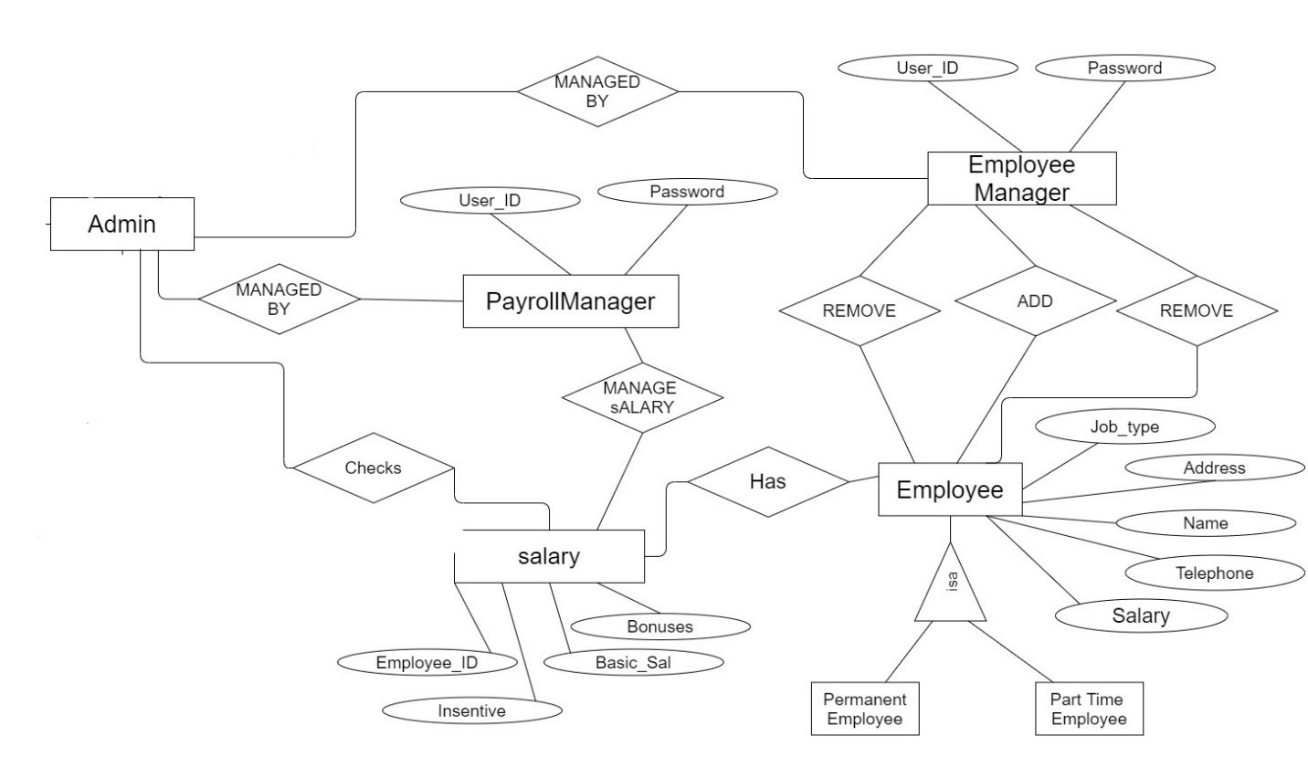

Entity Relationship Diagrams

Figure 2: Entity Relationship Diagram

Activity Diagrams

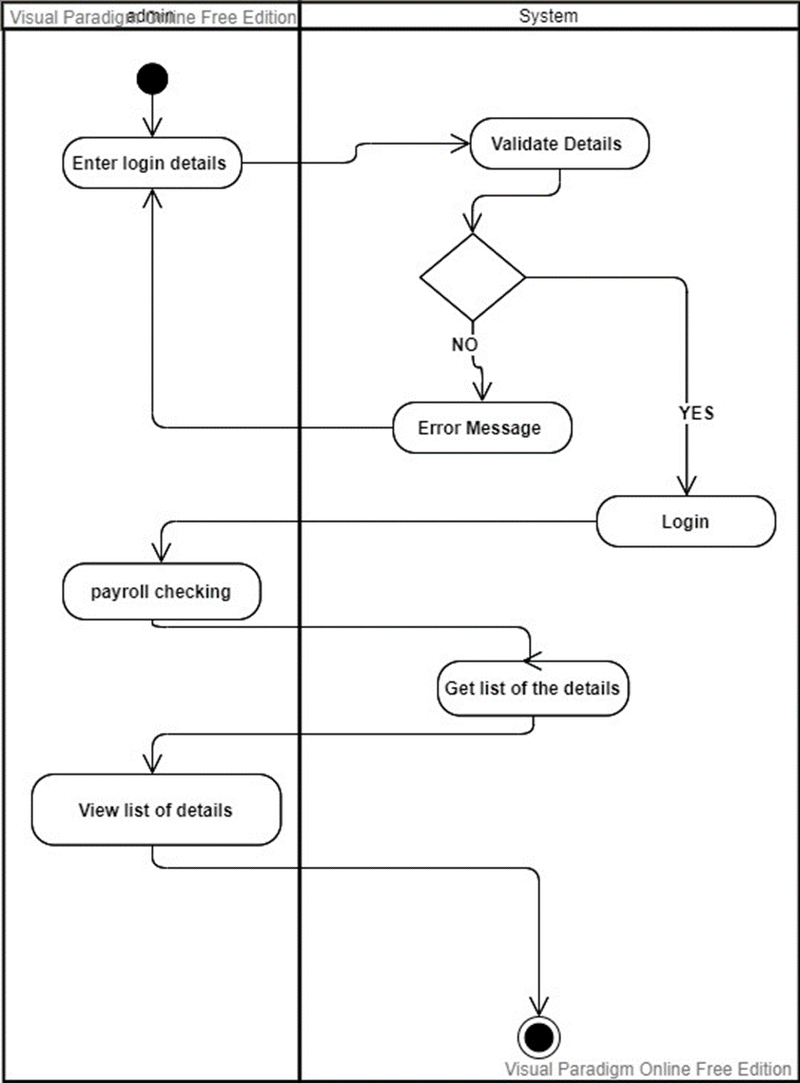

Figure 3: Activity Diagram - View Salaries
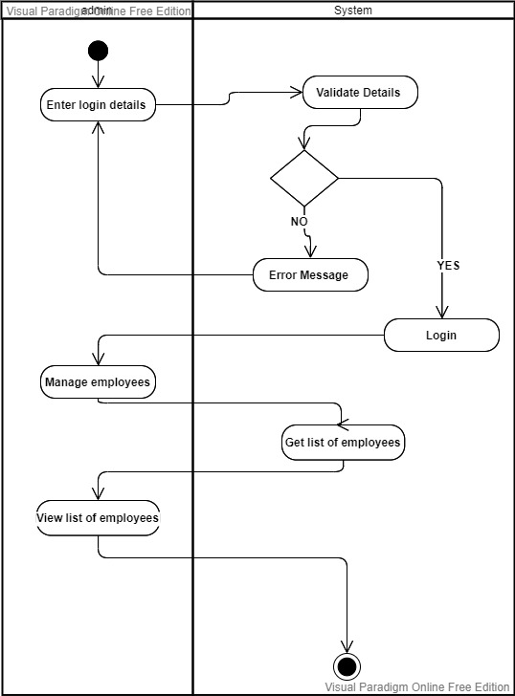

Figure 4: Activity Diagram - View Employees

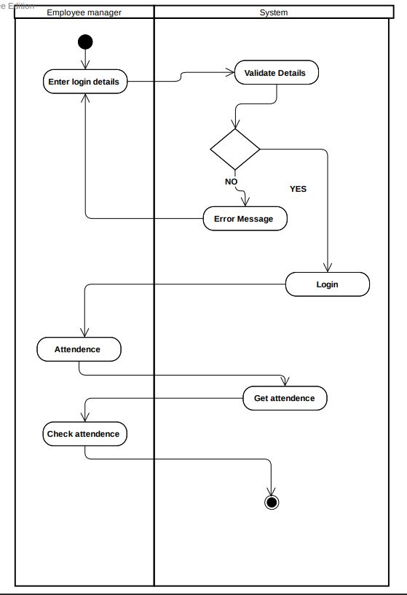

Figure 5: Activity Diagram - View Attendance

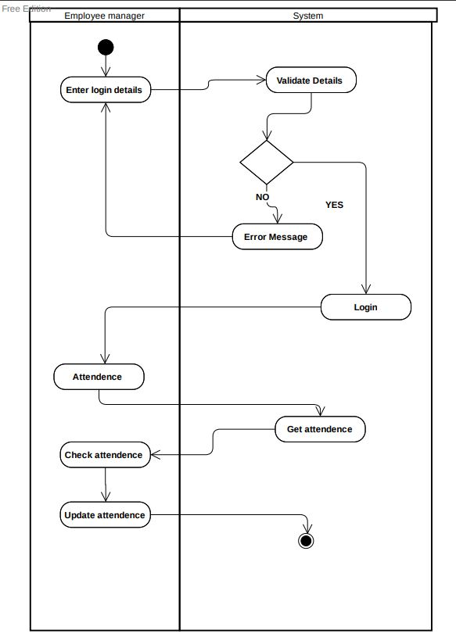

Figure 6: Activity Diagram - Update Attendance

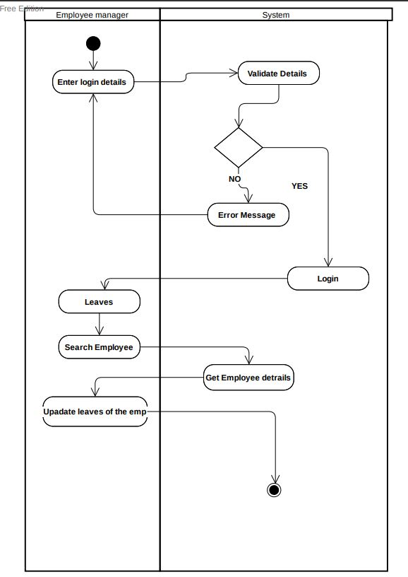

Figure 7: Activity Diagram - Update Employees

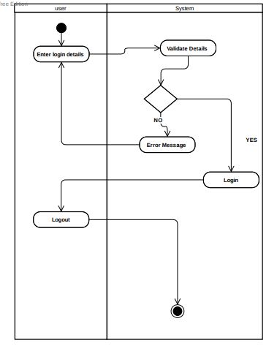

Figure 8: Activity Diagram - System Login

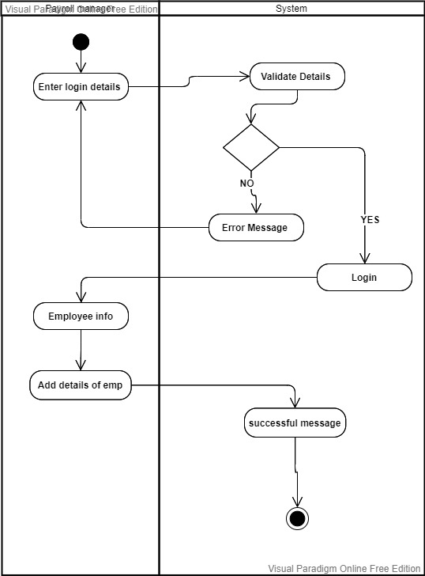

Figure 9: Activity Diagram - Add Employee Details

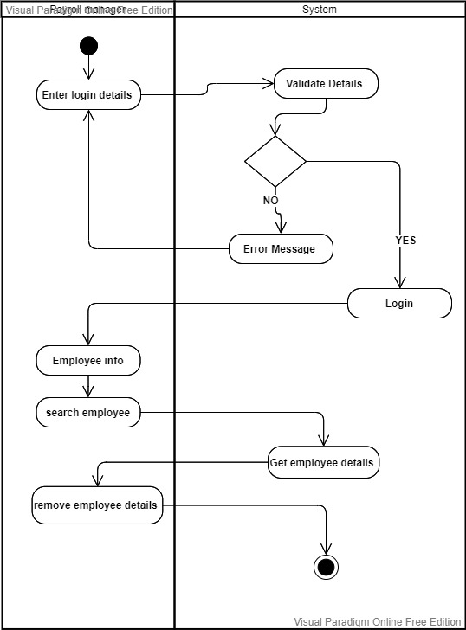

Figure 10: Activity Diagram - Remove Employees

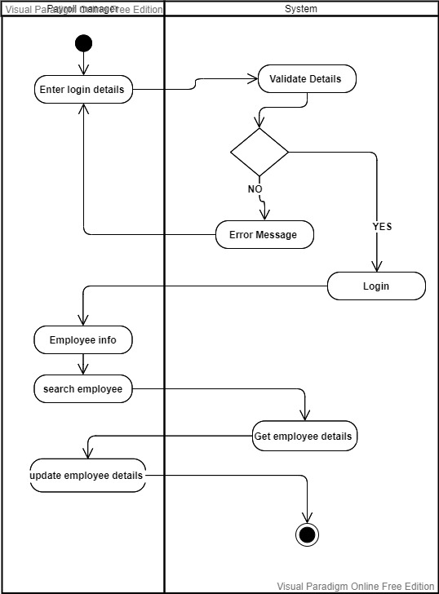

Figure 11: Activity Diagram - Update Employee Details
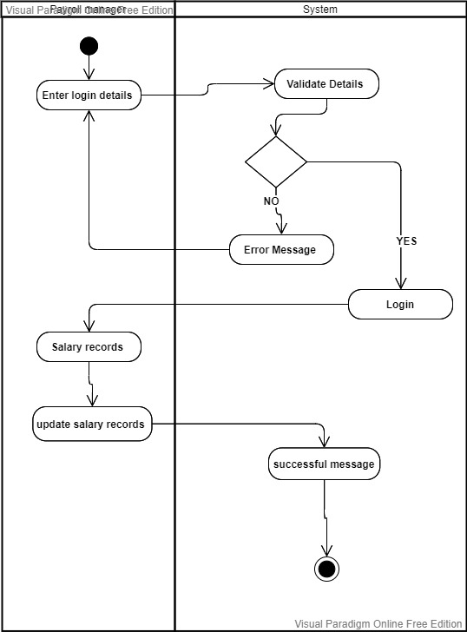

Figure 12: Activity Diagram - Update Salary Details

External Interface Requirements
The following are the conceptual designs that show product functionality and the user components that should be included in each screen. The final designs will capture the same components and functionality, but they might have a different design, which will be finalized after the selection of a suitable theme.

Common Interfaces for admin and Employees

Login

To access the system, all users and administrators must log in using valid credentials (User ID, Password). This is done to authenticate the user and maintain the systems and Employee information integrity to avoid unwanted threats and other concerns. This is a critical phase that is also a high-security necessity

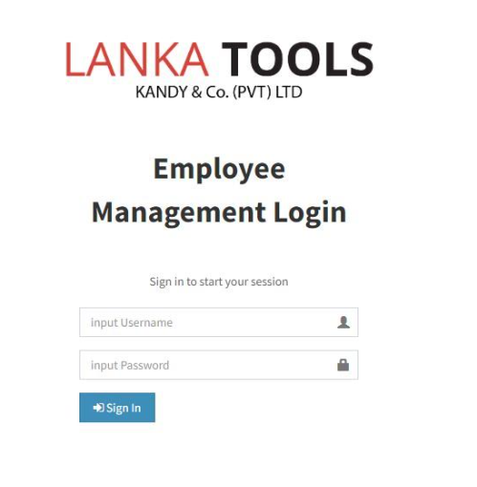
Figure 13 : Login Interface

View Employee Attendance
Both admin and Employee may use this interface to view attendance of employees or themselves.
When employee logged in the system attendance will filter based on the login.
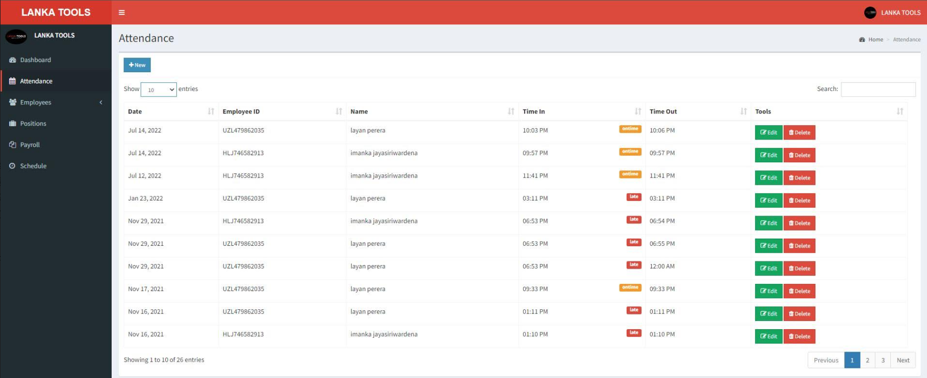
Figure 14: View Attendance interface

View Cash Advances
Both admin and Employee may use this interface to view cash advances entered of employees or themselves. When employee logged in the system attendance will filter based on the login.
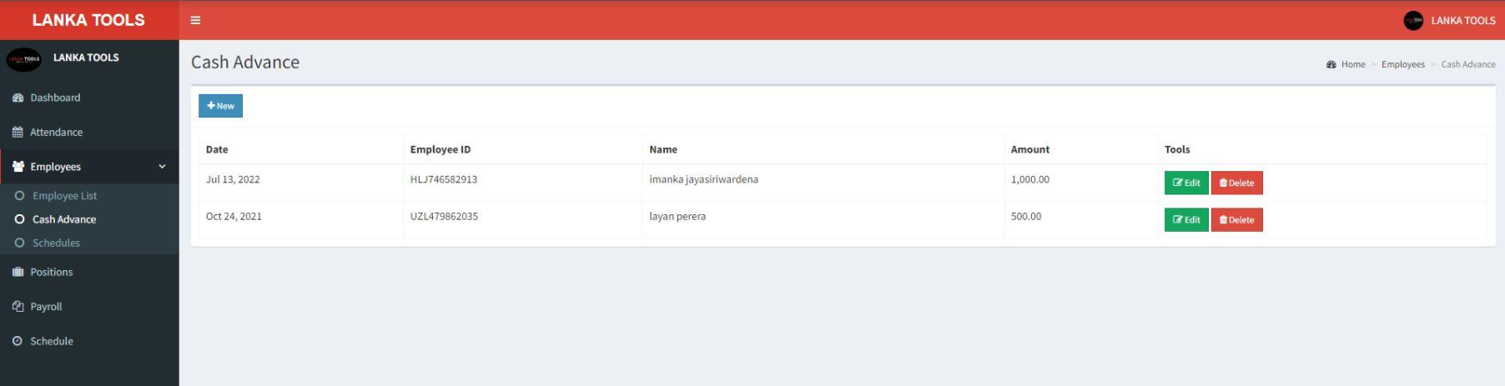

Figure 15: Cash advances interface

Admin Interface

Admin Dashboard
The Admin will redirect in to this page after login where he can view all employee monthly attendance, summary on Employee counts, on time percentages, on time employee count, late count.
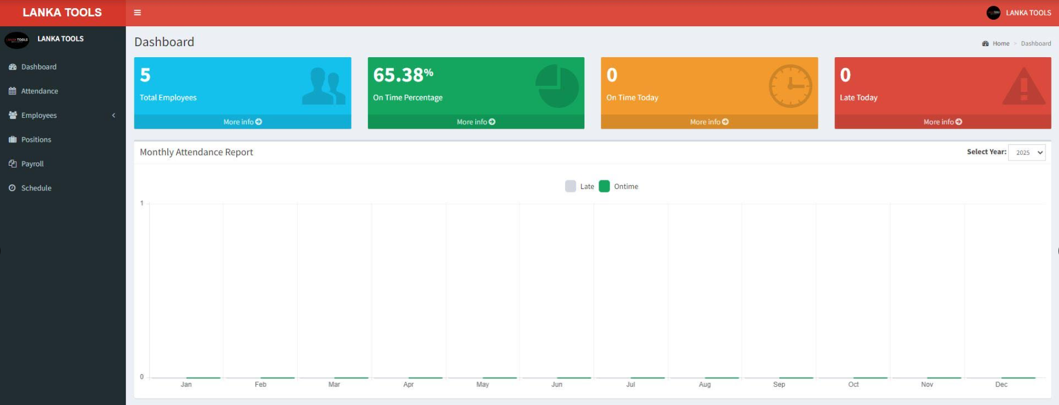

Figure 16: Admin dashboard

Employee Registration
This interface will be use by Admin to onboard employee and store details in the DB and Employee able to update his/her information once logged in to the system.
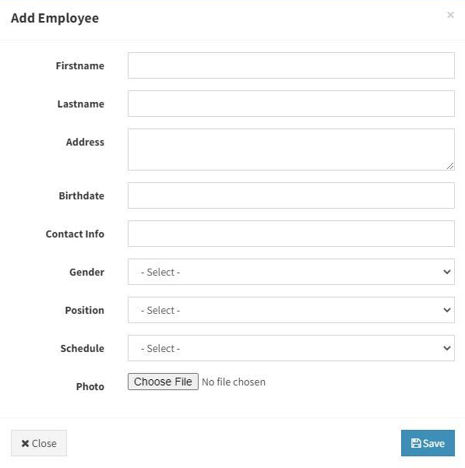

Figure 17 : Employee Registration Interface

Employee Roaster/Schedule management
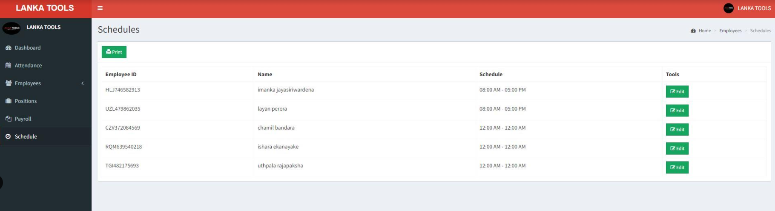
This Interface allows administrator to manage roster/schedule of each employee by giving In time and Out time

Figure 18: Schedule Management interface

View Payroll
Administrator able view salary scales, amounts, deductions and net pay of each employees via this interface
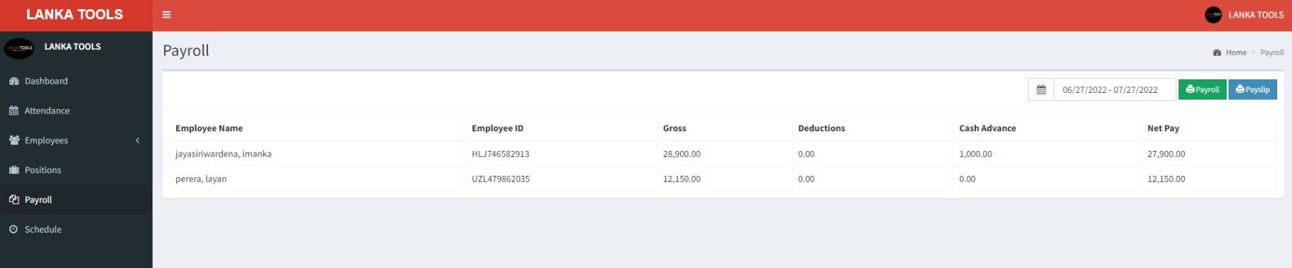

Figure 19: Payroll interface

User Interfaces

Add Attendance
This is the interface where employee enter their in time and out time in to the system

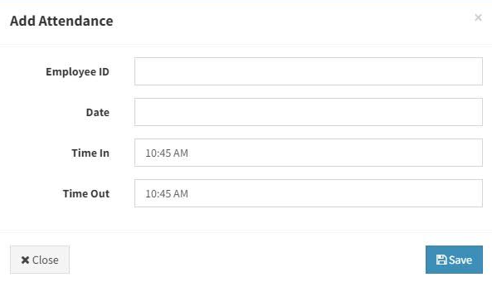

Figure 20: Add Attendance Interface

Add Cash Advance
This interface allows employee to enter the cash advance requests.

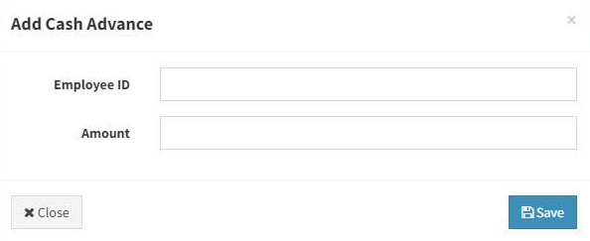

Figure 21: Add cash advance interface

Employee information Update
Employee allows to update their information exists in the system via this user interface.

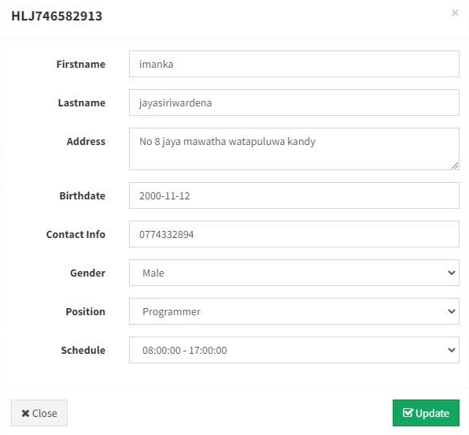

Figure 22: Employee Update interface

Software Interfaces

User Interface Prototyping
Figma will used to design mock interfaces for the web application.

Web Application
The front end and backend of the system will develop using following technologies with latest versions
- PHP
- HTML
- Bootstrap
- JavaScript & JQuery

Database
MySQL database will be used with backup procedures.

Communications Interfaces
This chapter explains the proposed communication mechanisms used by SMART Business Management system and the necessary steps to be taken to ensure the security of information with standard security compliances.

Communication functions
The communication architecture must follow the client-server model. Communication between the client and server will utilize a REST-compliant web services.

Communication Security
In order to secure sensitive information such as login credentials, Employee Information, Salary information all the communications will happen over the HTTPS protocol.

Other Nonfunctional Requirements
Non-functional requirements of the software requirement specification are discussed in this section under the subcategories of performance requirements, safety requirements, security requirements, and software quality aspects.

Performance Requirements
The proposed website is only highly efficient if performance criteria are stated. To evaluate performance requirements, the following criteria are used.

- Response Time
Any user interaction with the proposed Business management system should be quick and should complete within 10 seconds. The proposed web application should be interactive, and the system must respond quickly to each action in a shorter time. There should be no delays or interruptions in operations performed when connecting to the database. Also, actions such as linking, sorting, estimating, and publishing files required for storage will take less duration.
- Workload
The proposed system must be capable of assisting all users in fulfilling their tasks without any hassle
- Scalability
The proposed system should be able to manage and maintain the increased workload as the number of users continues to expand. As new users join, the system response time should be maintained. In case of a hardware limitation, the system should be able to be migrated to a better server.

Safety Requirements
Since all of the application's data is stored on a single database server, generating frequent backups is necessary in case of system failure. The system will include automatic backups regularly. These backups will be kept in secondary storage and stored securely. In addition, when operations such as deleting, there will be a confirmation notification that appears to assure authenticity. It is possible to obtain a report on change history about actions performed on the existing items.

Security Requirements
Due to the system information being sensitive in nature, data protection throughout storage, transmission, and storage is necessary to assure data security. All the data exchanged between the web browser and the web server will be encrypted using the HTTPS technology to prevent man-in-the-middle attacks. Confidential user data, such as passwords, will be encrypted before being saved into the database. All user access and modifications will be recorded in the system for reference purposes. Safety is a system's capability to minimize the risk of malicious or unexpected actions beyond the system's intended usage and to prevent security breaches or losses.

The suggested system guarantees protection against potential attacks. Include solutions for forgotten passwords, account lockouts, idle session expiration, and avoiding storing plain text passwords, among other things. The vital principle is that a user's activity or data should not be changed in any manner between the time it leaves the user's computer and the time it is recorded in the database.

Software Quality Attributes
In this section, the software quality attributes of the SRS are discussed through developer productivity, elegance, usability, security, reliability, performance, scalability, testability, interoperability, transparency, and troubleshooting.

- Usability – The system should be created and built according to the specifications and restrictions determined throughout the review process. All interactions should be tested in various scenarios, including those that are unusual. Check to see if the system can consistently produce the desired results. The system should be simple to use and navigate without lagging. Even someone with minimal technical understanding should be able to access and navigate the system.
- Reliability – The system's reliability derives from the usability mentioned above. The system should always give accurate information. There shouldn’t be discrepancies between what’s shown to the user and what is actually recorded in the database.

- Learnability – With minimum computer literacy, any user should be able to operate the system.

- Maintainability – It should be hassle-free to troubleshoot issues and modify or extend the website's functionalities. Admin should be able to rapidly and efficiently create, read, update and delete data.

Other Requirements
Apart from the things that will be changed throughout the project, current content must be added to the database ahead of time to ensure a smooth application launch. With this data migrations and configurations required modules will and functionalities will all work seamlessly after implementation.

Appendix A: Glossary
Term | Definition
SRS | Software Requirement Specification
ER Diagram | Entity Relationship Diagram

